1 Search Algorithms

Basic State Model: Classical Planning

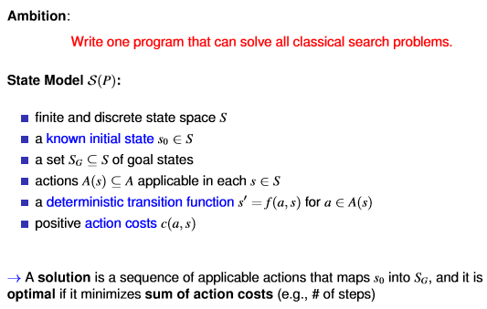

Search Terminology

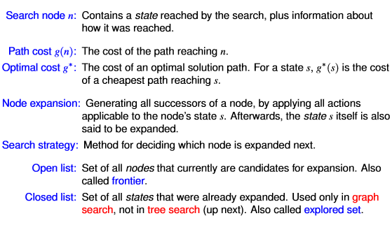

Criteria for Evaluating Search Strategies



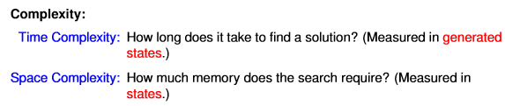



Breadth-First Search

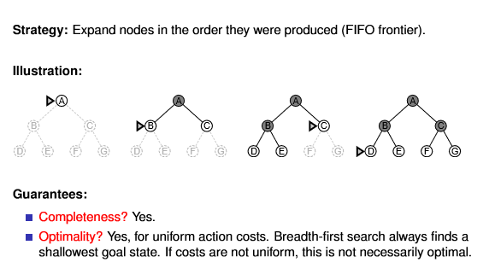

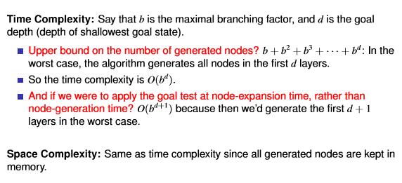

Depth-First Search

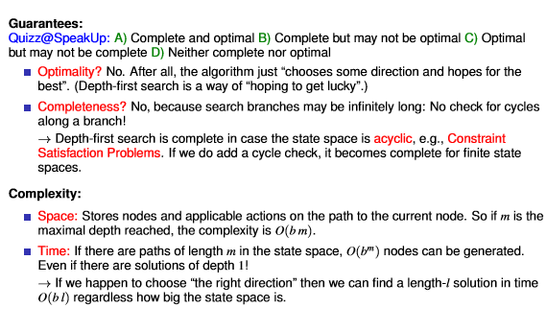

Iterative Deepening Search

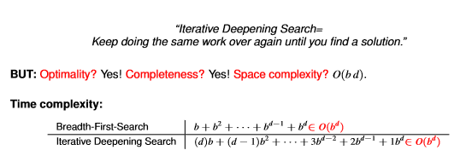

Heuristic Functions

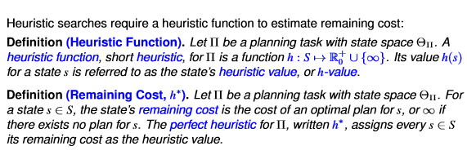

Properties of Heuristic Functions

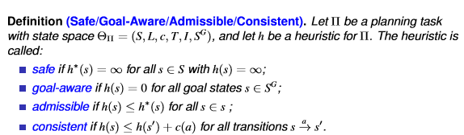

Greedy Best-First Search

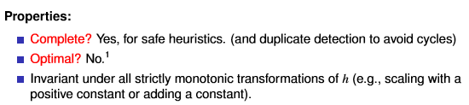

A∗

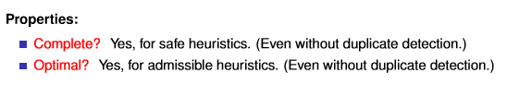

Weighted A∗

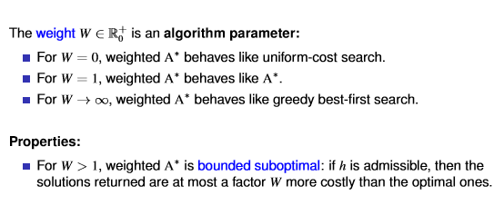

Hill-Climbing

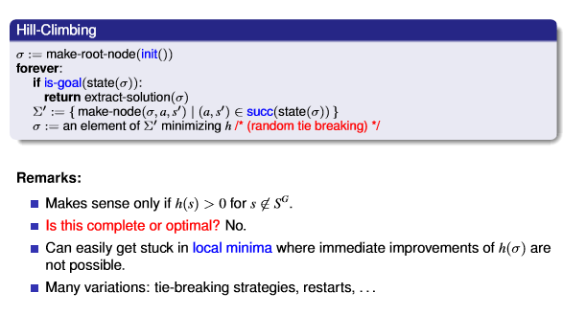

Enforced Hill-Climbing

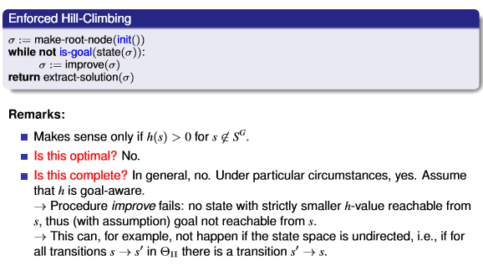

Properties of Search Algorithms

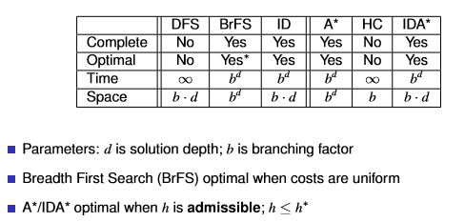

2 Introduction to Planning

Programming-Based Approach



Learning-Based Approach



Model-Based Approach

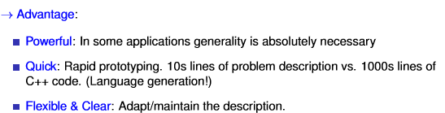

Models, Languages, and Solvers

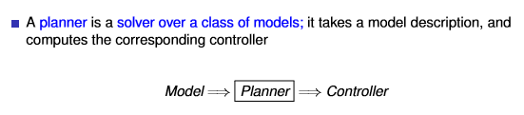

Strips

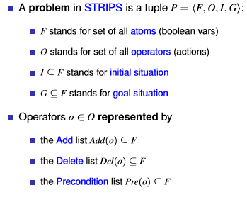

Decision Problems in Planning

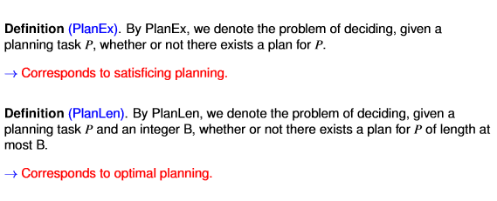

3 Generating Heuristic Functions

Relaxations

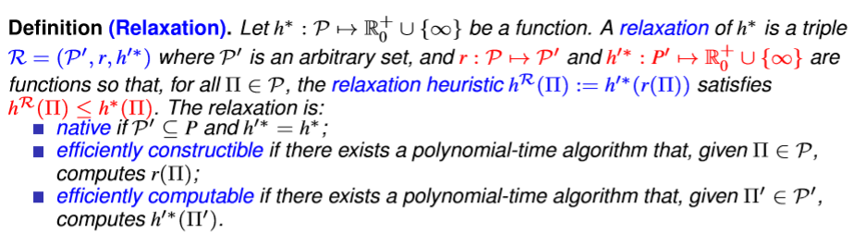

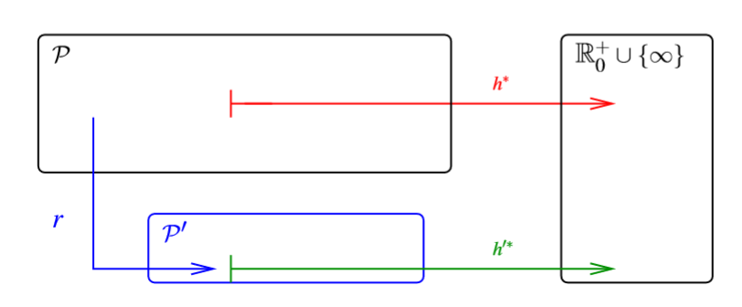

Native Relaxations

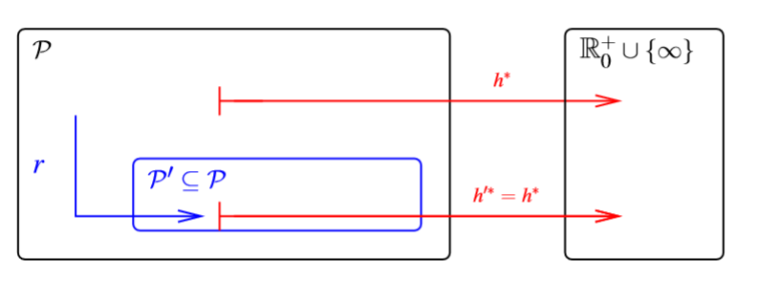

How to Relax During Search: Diagram

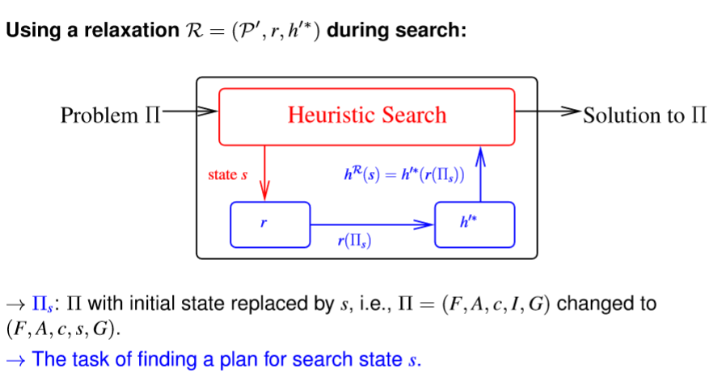

The Delete Relaxation

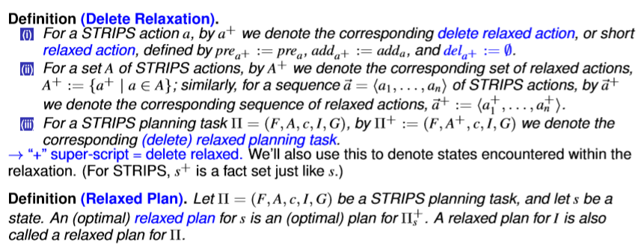

State Dominance

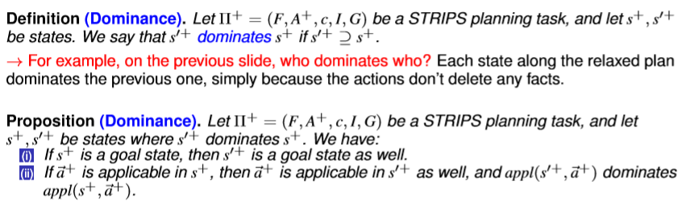



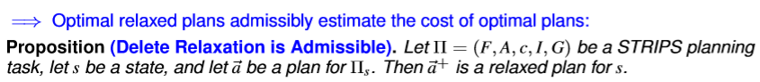

Greedy Relaxed Planning

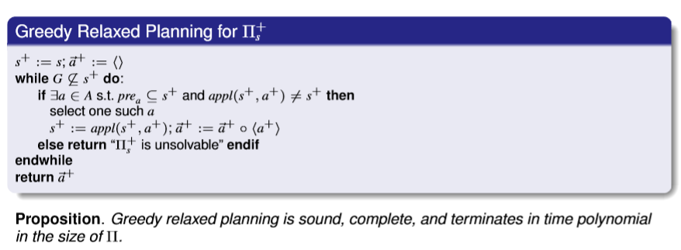

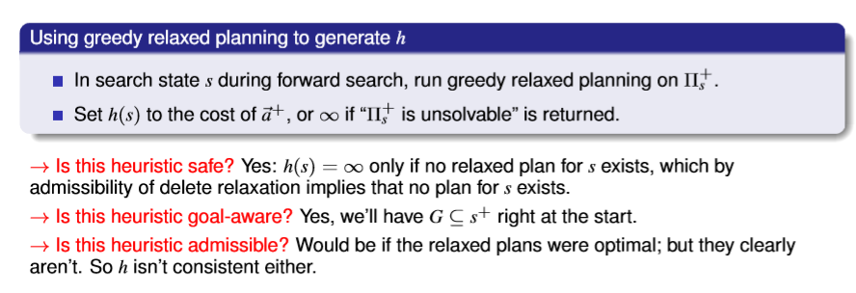

h+: The Optimal Delete Relaxation Heuristic

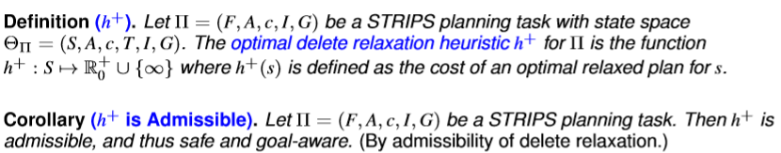



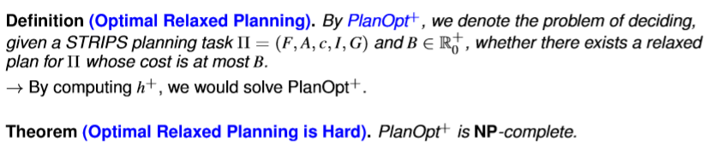

h+ as a Relaxation Heuristic

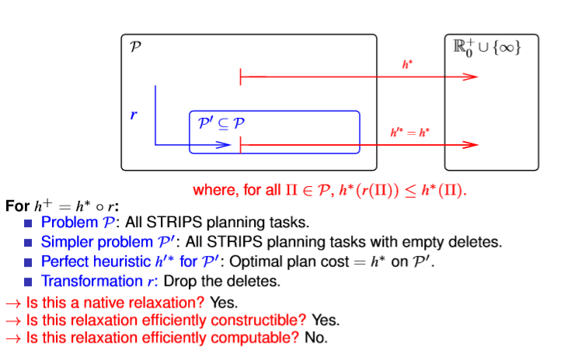

The Additive and Max Heuristics

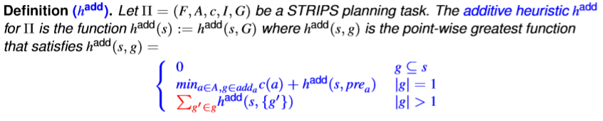

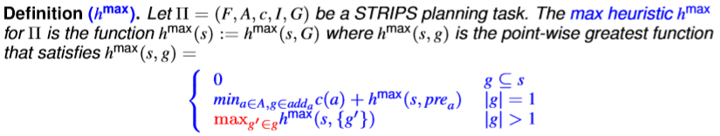

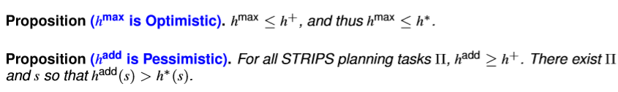



Bellman-Ford for hmax and hadd

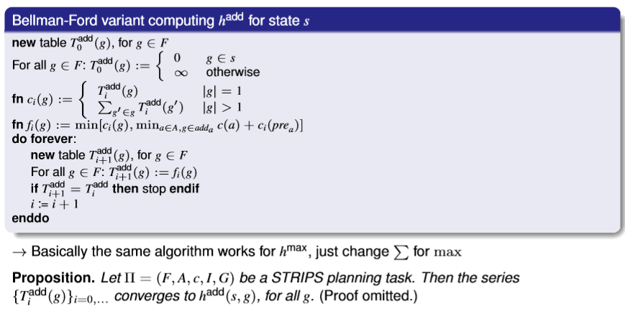

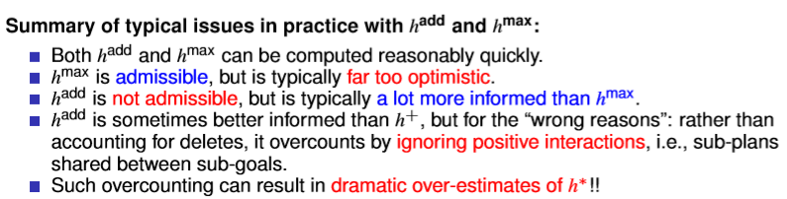

Relaxed Plan Extraction

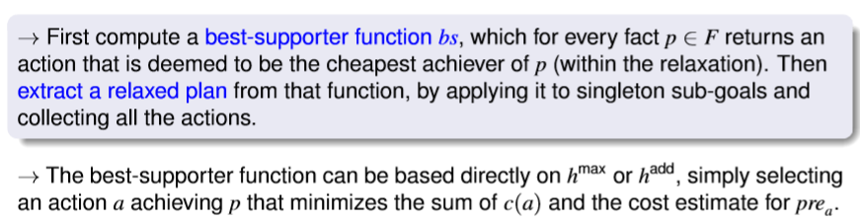

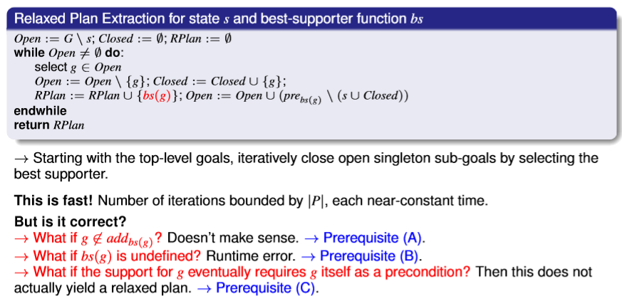

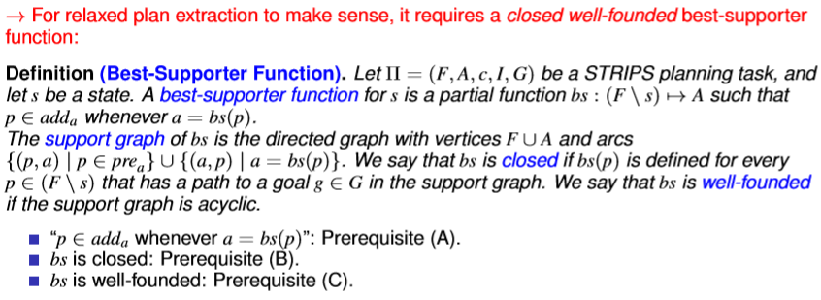

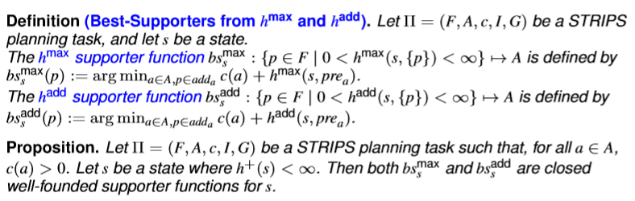



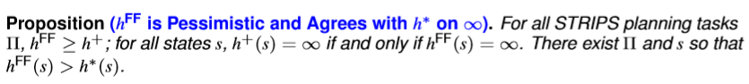

4 Markov Decision Processes (MDPs)

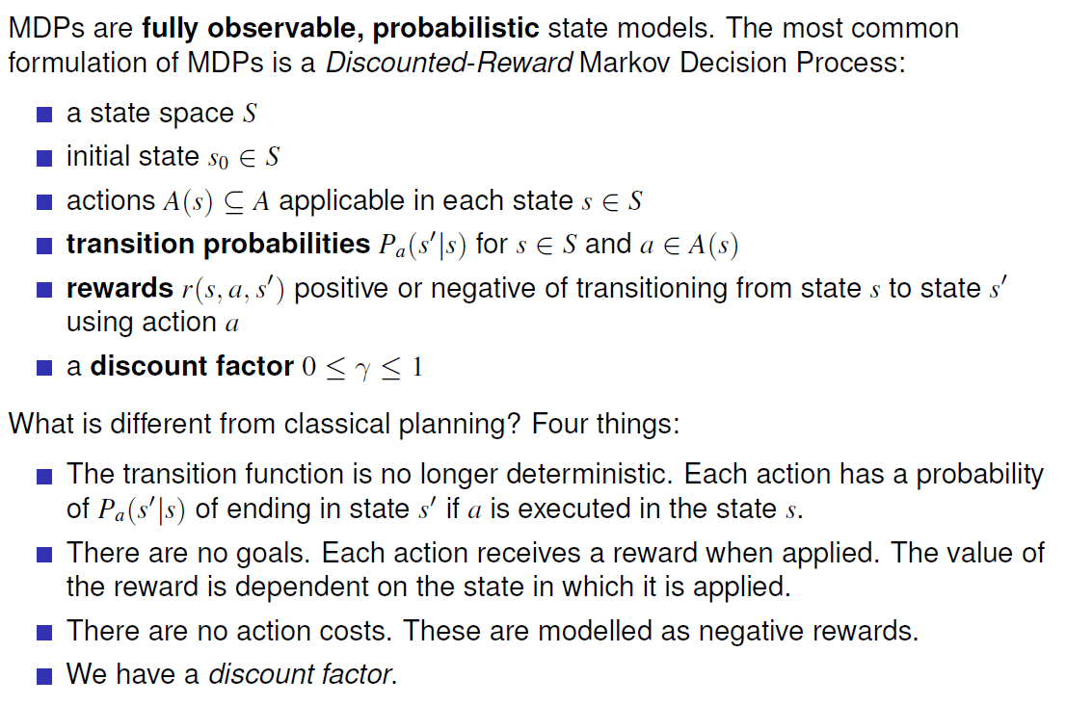

Expected Value of Policy for Discounted Reward MDPs

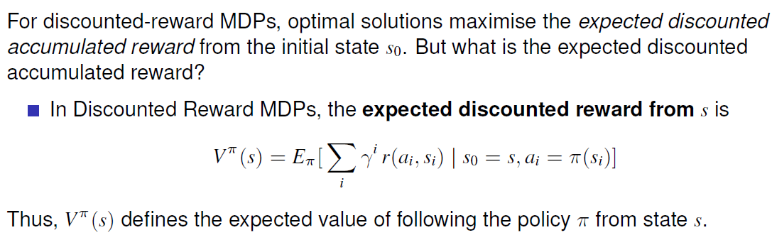

Bellman equations (Discounted-Reward MDPs)

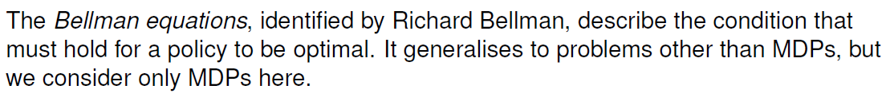

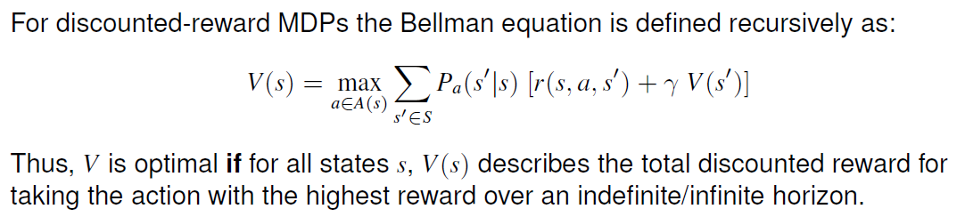

Value Iteration

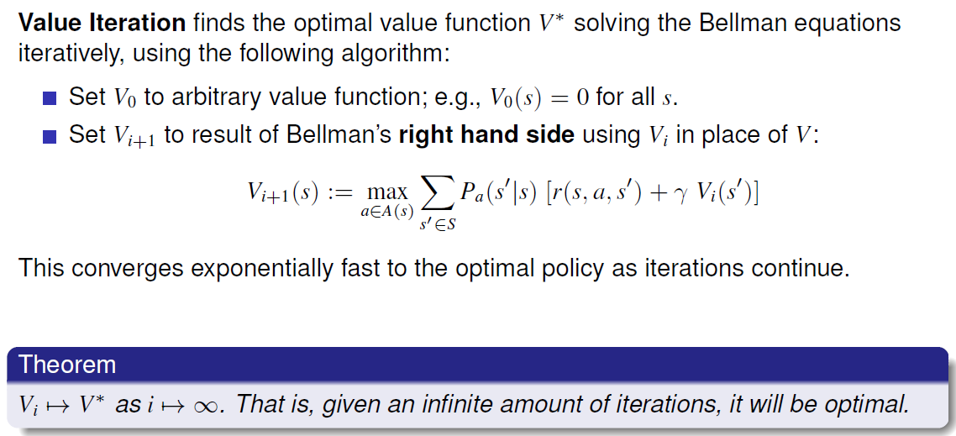

Policy evaluation

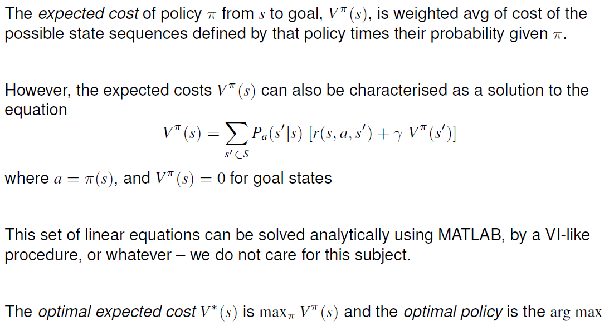

Policy Iteration

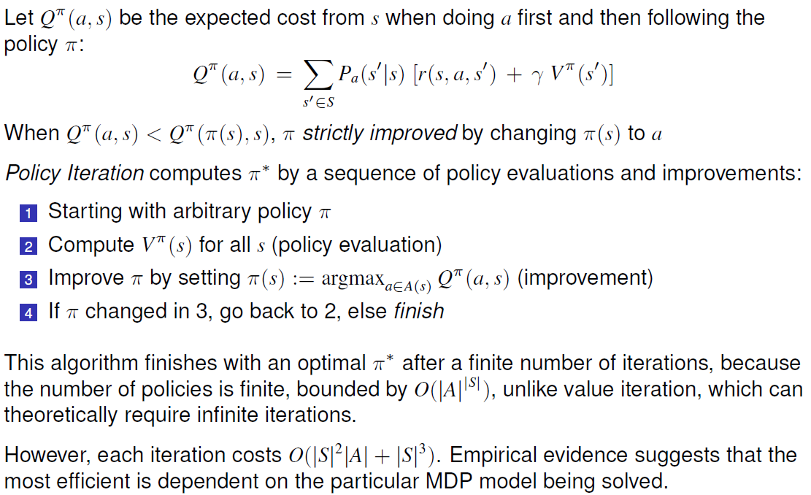

5 Monte Carlo Tree Search

Monte Carlo Tree Search

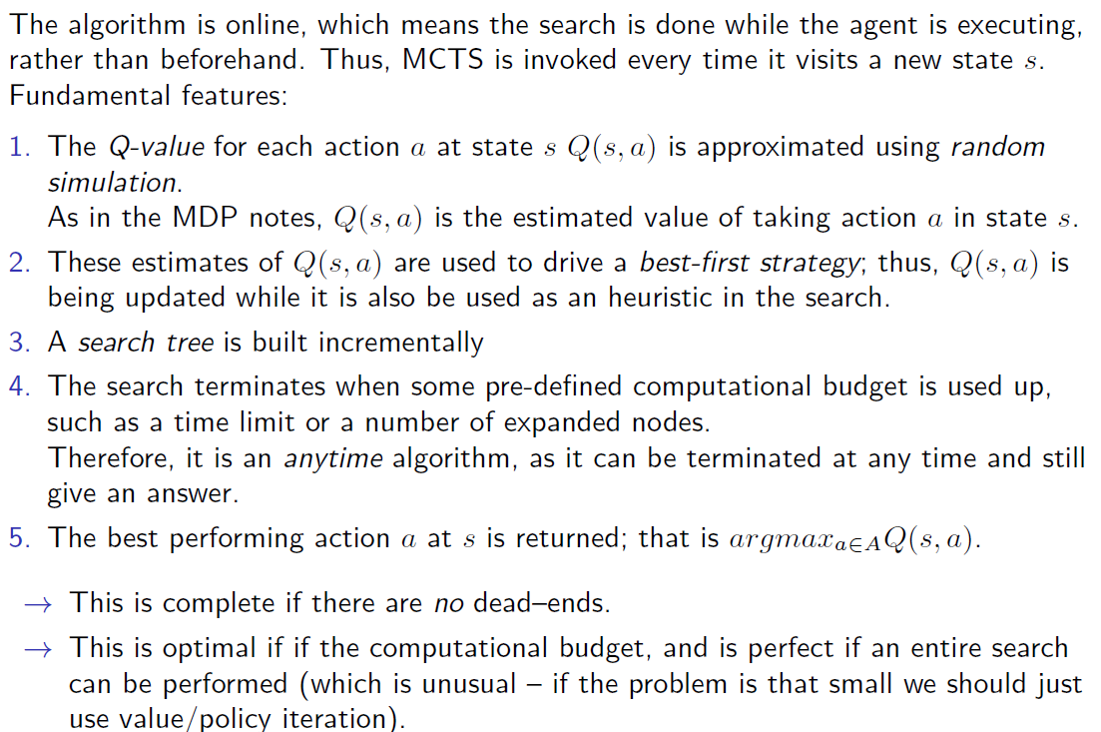

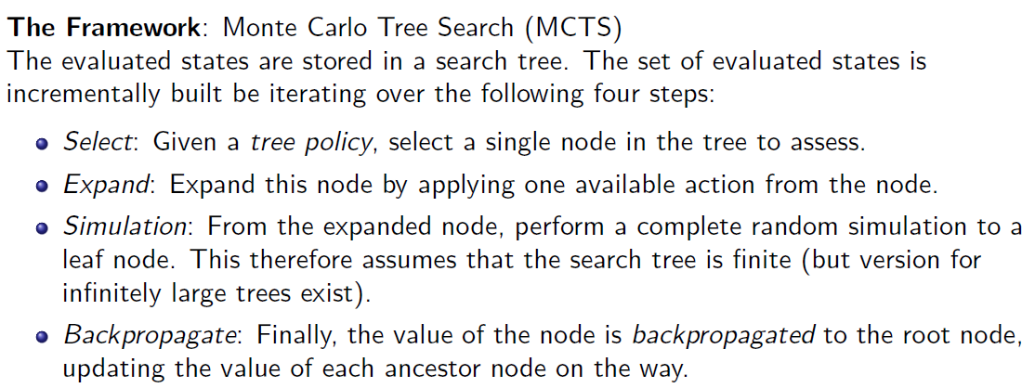

Multi-Armed Bandit

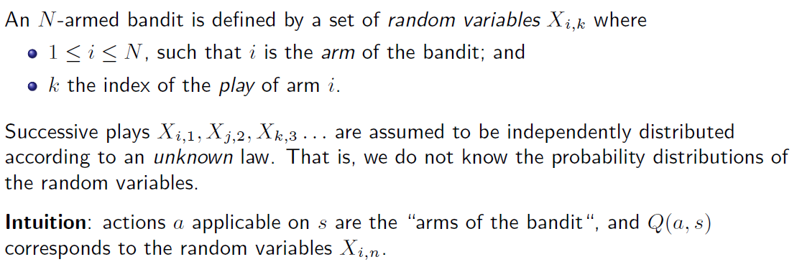

Exploration vs. Exploitation

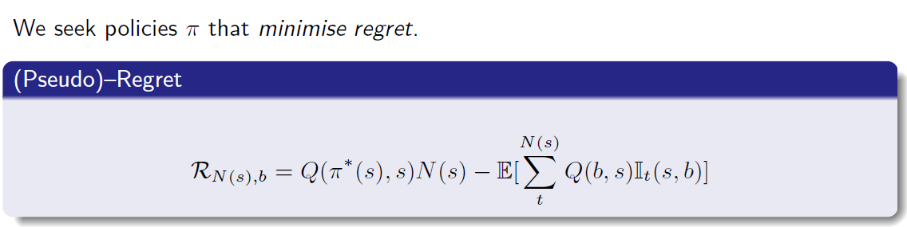

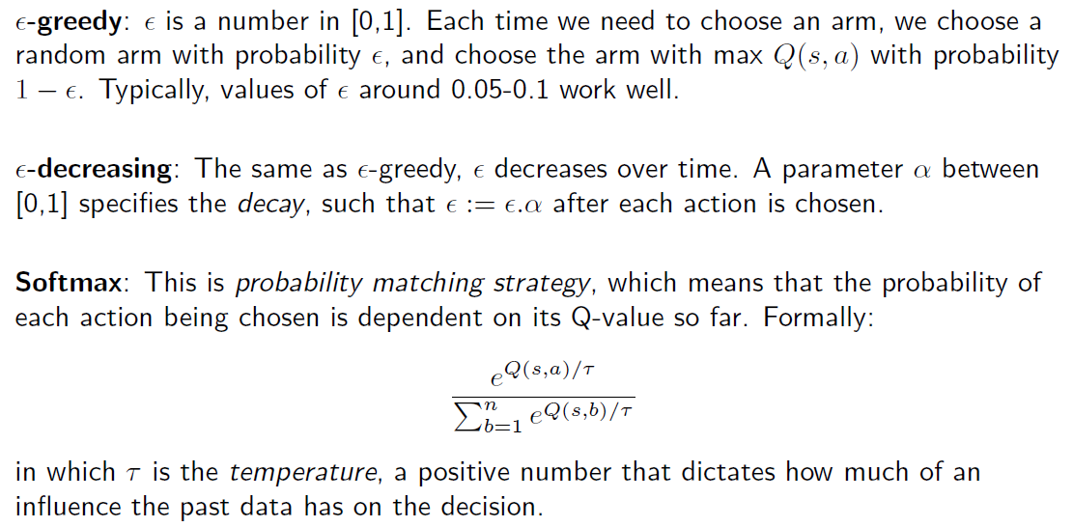

Upper Condence Bounds (UCB1)

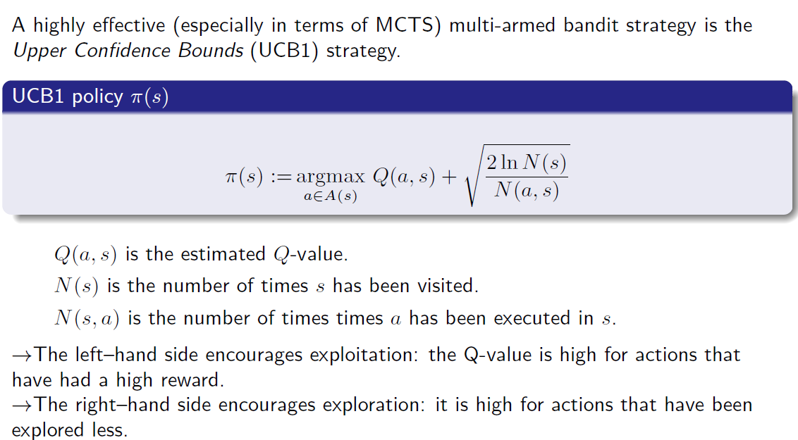

Upper Condence Trees (UCT)

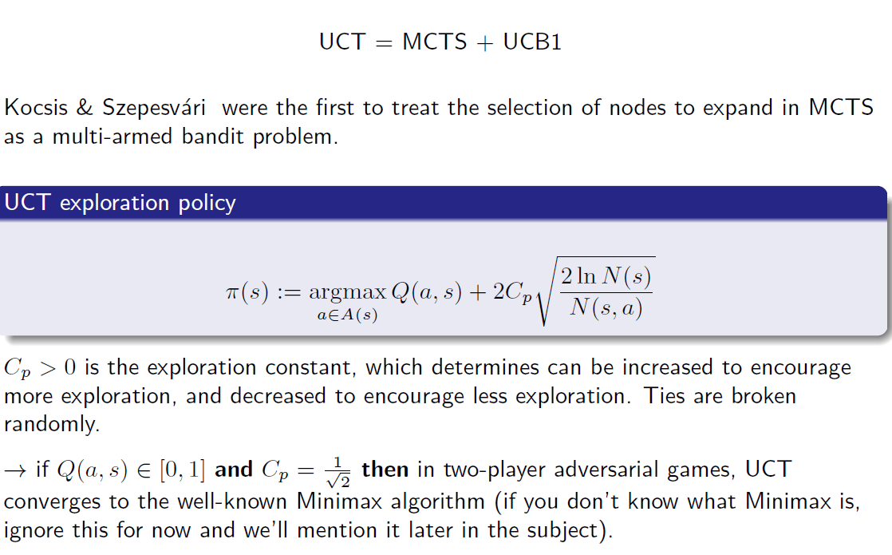

6 Reinforcement Learning

Reinforcement Learning

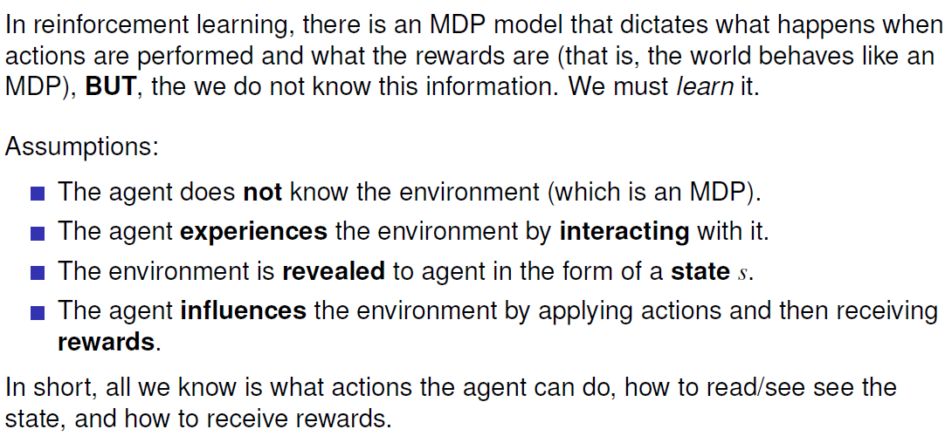

Q-Learning

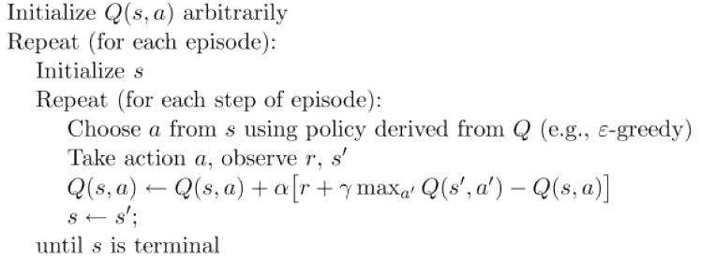

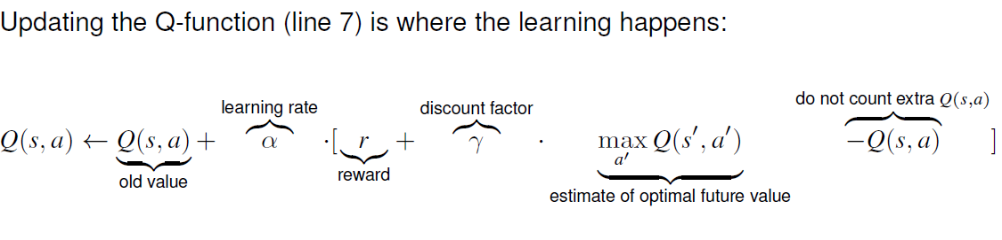

SARSA: On-Policy Reinforcement Learning

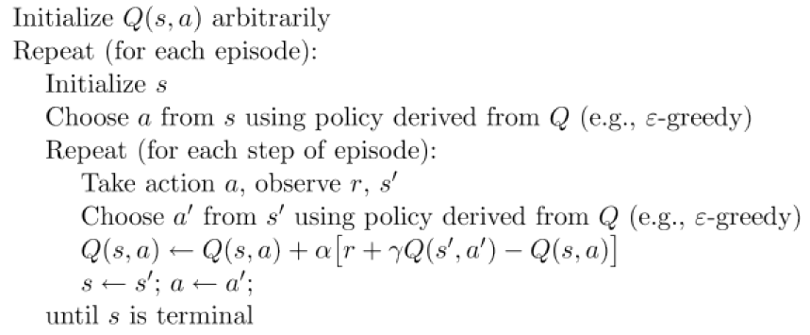

Q-learning vs. SARSA



